**Project Details**

|  |  |
| --- | --- |
| Project number | *12* |
| Project title | *Mega store corporation* |
| Corresponding TA\LA | *TA/Dina Abbas* |
| Deliverable | *2* |

**Team Details**

|  |  |  |
| --- | --- | --- |
| **Student ID** | **Student name** | **Lab Group** |
| 20200076 | Esraa Mohamed Abdel satar | S3 |
| 20201024 | Alaa essam ali | S5 |
| 20201202 | Norhan Hassan Ali Elsadiq | S7 |
| 20200618 | Hala Gamal Meselhy | S4 |
| 20200599 | Nagham hassan abu elfath | S7 |
| 20200093 | Omnya alaa korany | S8 |
| 20201178 | Mennat allah Mohamed Ibrahim el sharawy | S7 |

**1.** **CRUD technique:**

Verify use cases using CRUD technique (e.g. Fig 5-12)

|  |  |  |
| --- | --- | --- |
| Domain Class | CRUD | Verified Use case |
| product | create | Purchase a product |
|  | Update | Purchase a product |
|  | Create | Return Product |
| warehouse | Read/ Report | Provide product |
|  | Create | Store product |
|  | Read/ Report | Make reports |
|  | Read/ Report | Delete product |
|  | Read/ Report | Add product |
| customer | Create | Buy product by offsite way |
|  | Create | Return Product |
|  | Create | Buy product by onsite way |
|  | Read/report | Check search history |
|  | Read/report | Check purchase history |
|  | Read/ Report | Add offers |
|  | Update | Gain points |
| Supplier | Create | Provide product |
|  | Create | Store product |
| store | Read/report | Search a product |
|  | Update /Delete | Provide products |
|  |  |  |
|  | Update / Delete | store products |
|  | Read/ Report | Buy product by offsite way |
|  | Read/ Report | Buy product by onsite way |
|  | Create / Update | Add product |
|  | Delete / Update | Delete product |
|  | Create | Make reports |
|  | Create | Add offers |
|  | Create | Add store |
|  | Delete | Delete store |
| offers | Update | Purchase a product |
|  | Update | Add product |
|  | Read/ Report | Add offers |
|  | Create | Gain points |
|  | Create | Provide offers |
|  | Read/ Report | Check occasion.  Check event requirements.  Check country. |
| purchase | Create | Buy product by onsite way |
|  | Create | Buy product by offsite way |
|  | Read | Gain points |
| category | Read/report | Choose a product category |
| Sale assistent | Read/report | Check date |
|  | Read/report | Check Product Categories |
|  | Update | Return money by cash |
|  | Update | Return money by Credit Card |
|  | Read/report | Get Customer information |
|  | Update | Provide point |

CRUD table showing use cases and corresponding domain classes (e.g. Fig 5-13)

|  |  |  |  |  |  |  |  |  |  |
| --- | --- | --- | --- | --- | --- | --- | --- | --- | --- |
| Use case vs. entity/domain class | product | warehouse | customer | supplier | store | offers | purchase | Sale assistent | Categoy |
| Provide products |  | R |  | C | U / D |  |  |  |  |
| Store product |  | C |  | C | U/ D |  |  |  |  |
| Purchase a product | U |  | C |  | R | U | C |  |  |
| Search a product | R | R |  |  | R |  |  |  |  |
| Add product |  | R |  |  | C / U | U |  |  |  |
| Choose product category | R |  | C |  |  |  |  |  |  |
| Make reports |  | R |  |  | C |  |  |  |  |
| Delete product |  | R |  |  | D / U |  |  |  |  |
| Add offers |  |  | R |  | C | R |  |  |  |
| Delete store |  |  |  |  | D |  |  |  |  |
| Add store |  |  |  |  | C |  |  |  |  |
| Gain points |  |  | U |  | C |  | R |  |  |
| Provide offers |  |  |  |  |  | C |  |  |  |
| Check occasion |  |  |  |  |  | R |  |  |  |
| Check event requirements |  |  |  |  |  | R |  |  |  |
| Check search history | R |  | R |  |  |  | R | R |  |
| Check purchase history | R |  | R |  |  |  | R | R |  |
| Check country |  |  |  |  |  | R |  |  |  |
| Return product | C |  | C |  |  |  |  | R |  |
| Check date |  |  |  |  |  |  | R | R |  |
| Check Product Categories |  |  |  |  |  |  |  | R | R |
| Return money by cash |  |  |  |  |  |  |  | U/D |  |
| Return money by Credit Card |  |  |  |  |  |  |  | U/D |  |
| Get Customer information |  |  | R |  |  |  |  | R |  |
| Provided point |  |  | U/D |  |  |  |  | U/D |  |

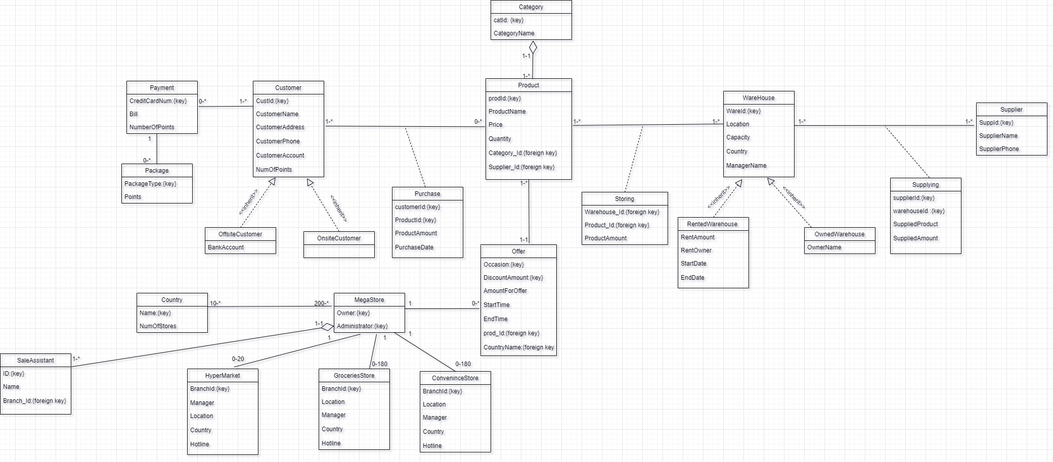**2. Domain Class Model**

**3. State Machine Model**

**Return a product**

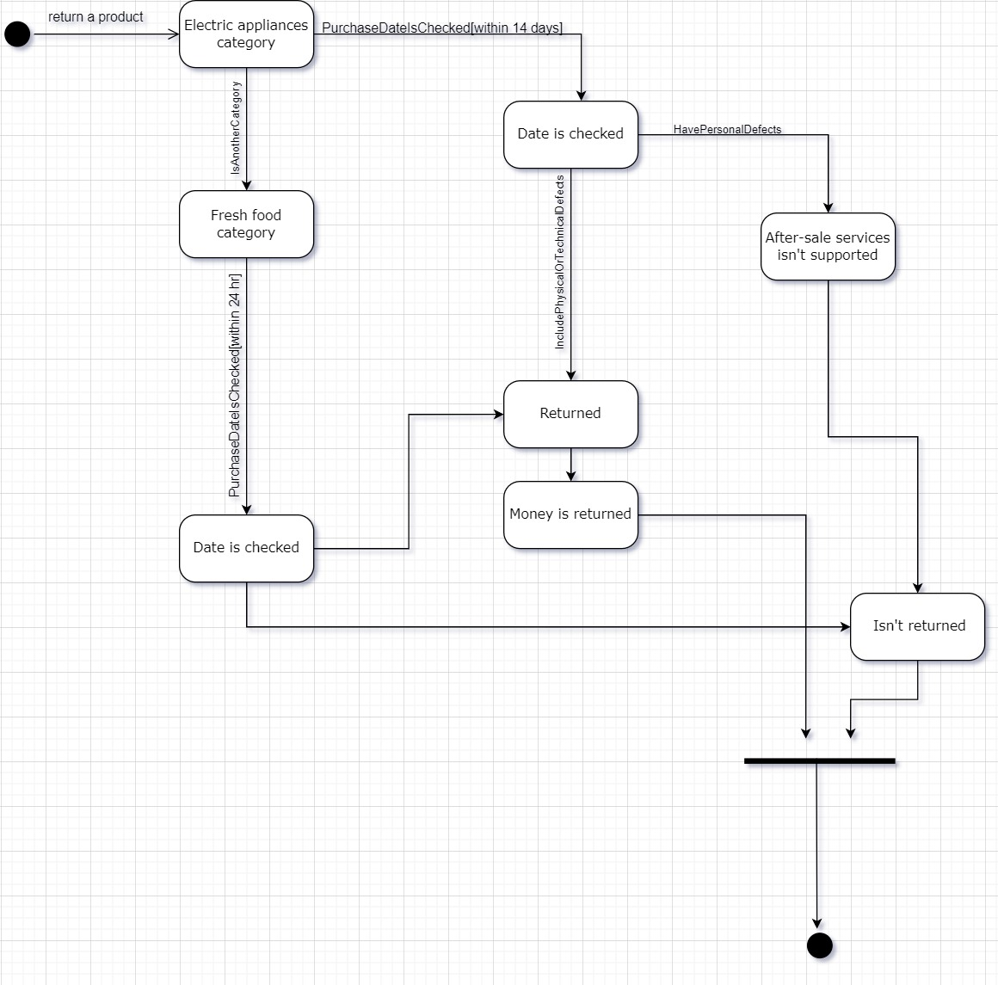

**4. Activity Diagrams**

**Activity 1 (Offers)**

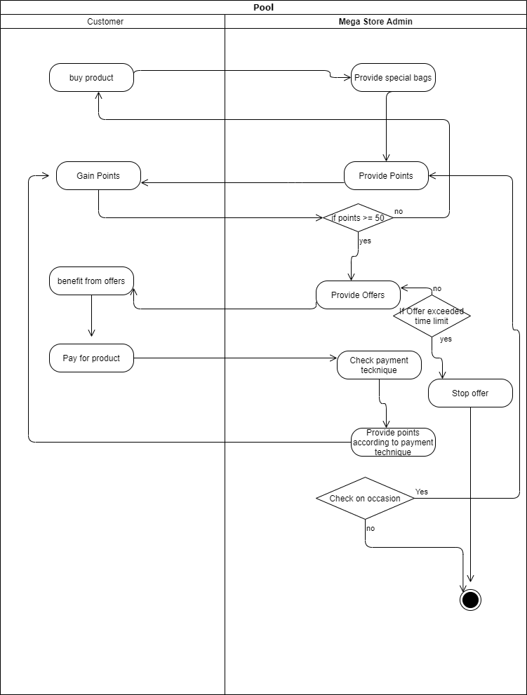

**Activity 2 (Provide product)**

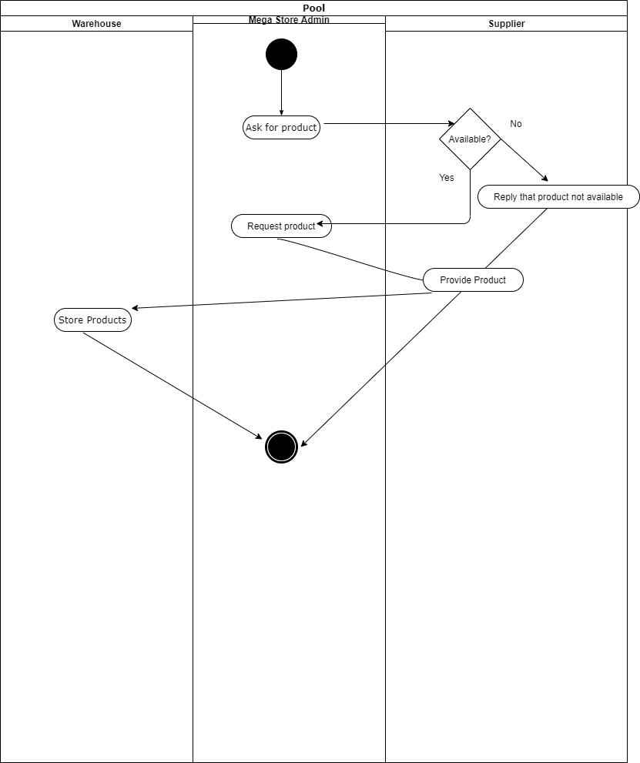

**Activity 3 (Purchase a product)**

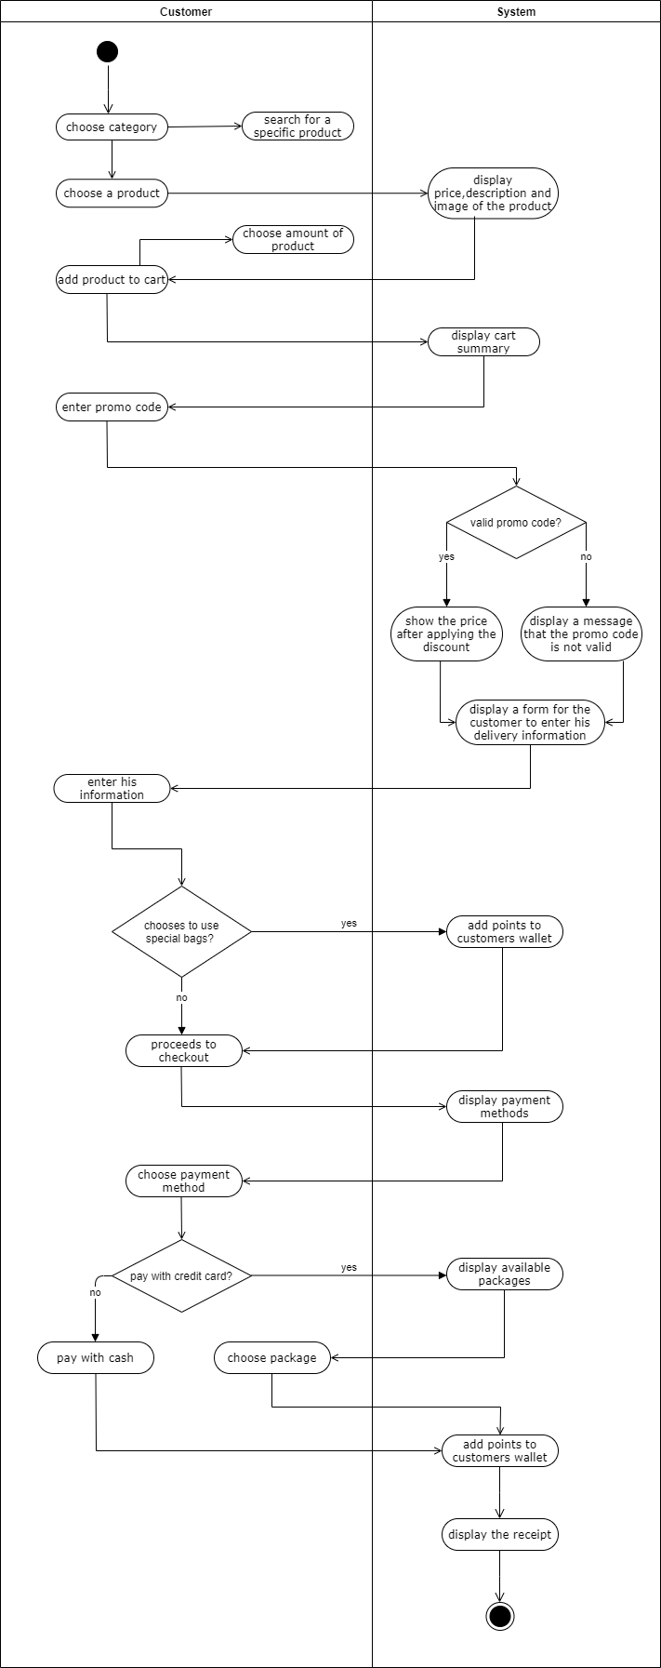

**Activity 4 (Return a product)**

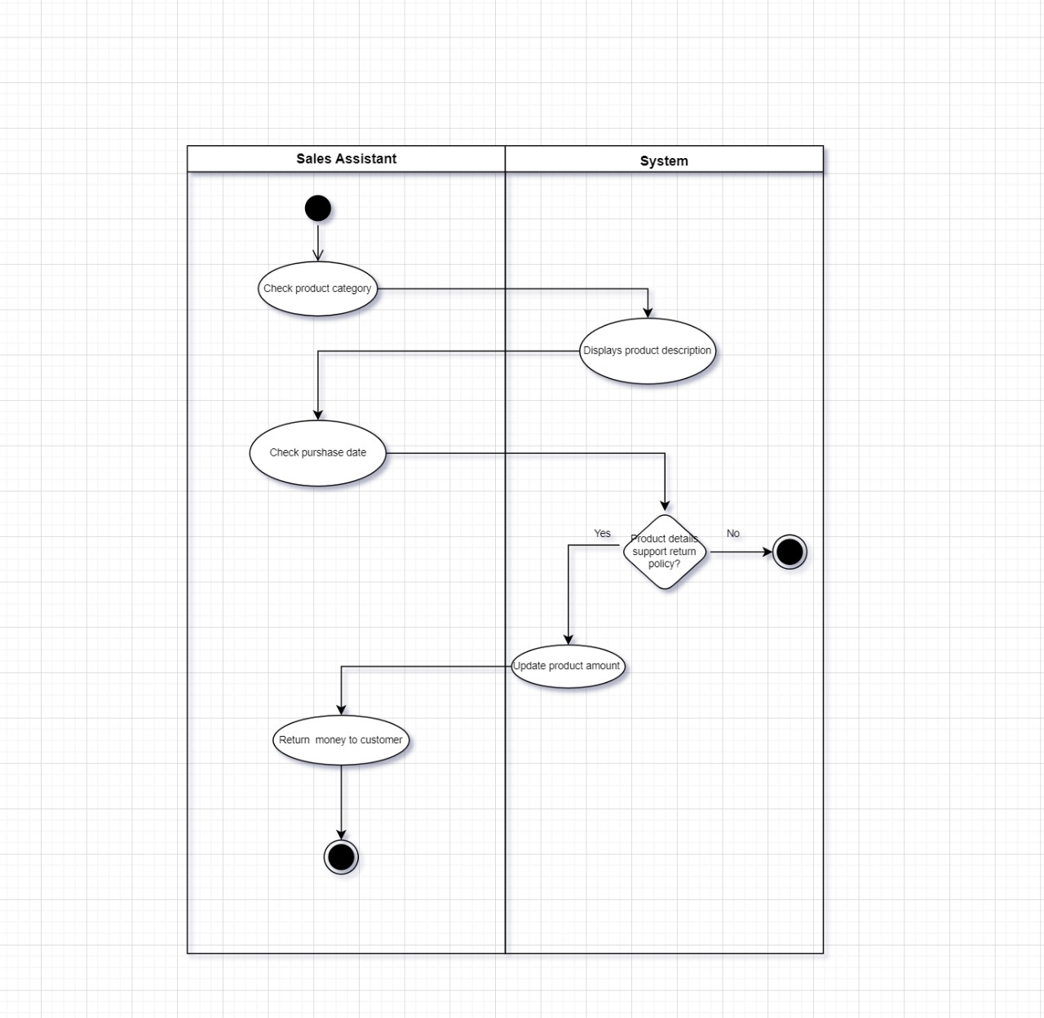

**5. System Sequence Diagrams**

**Sequence 1 (Offers)**

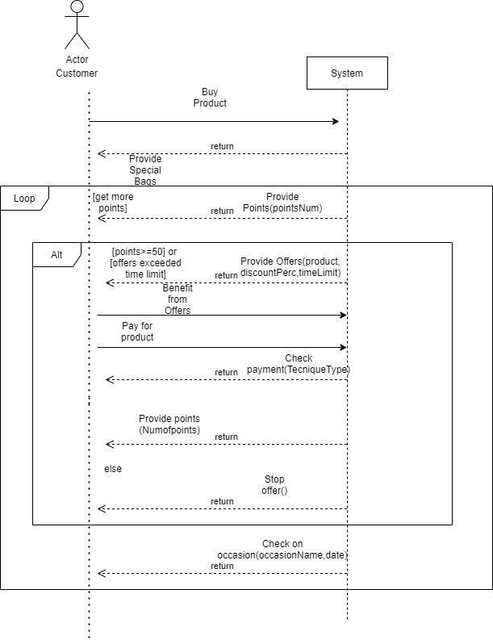

**Sequence 2 (Provide product)**

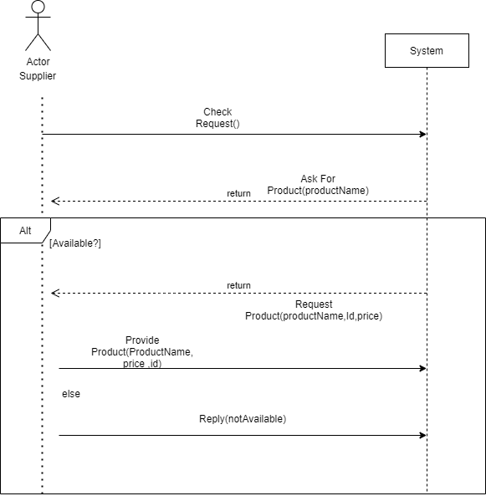

**Sequence 3 (Purchase a product)**

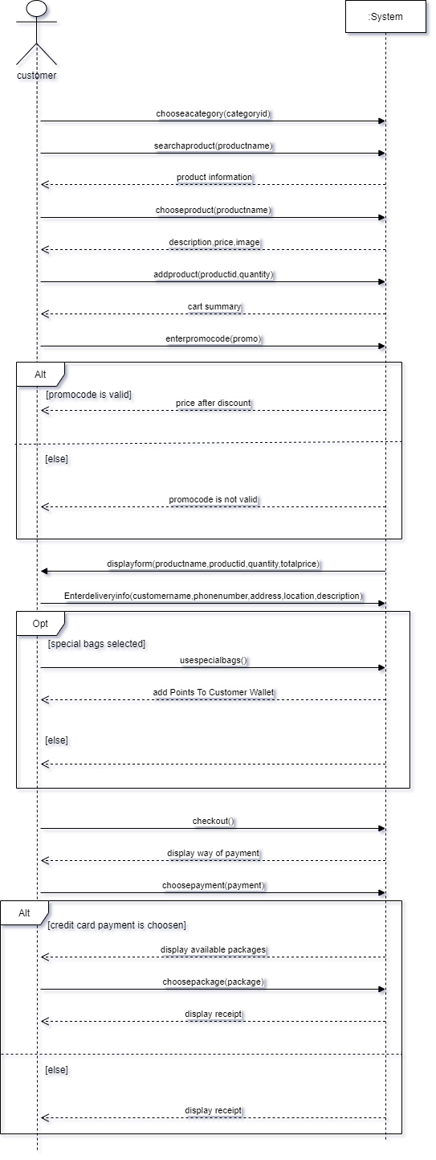

**Sequence 4 (Return a product)**

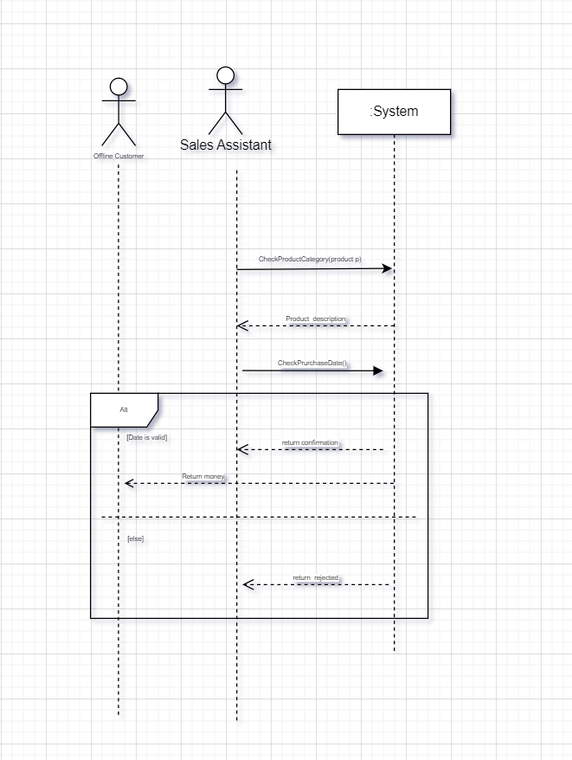

**-Draw.io tool was used for designing all the diagrams**